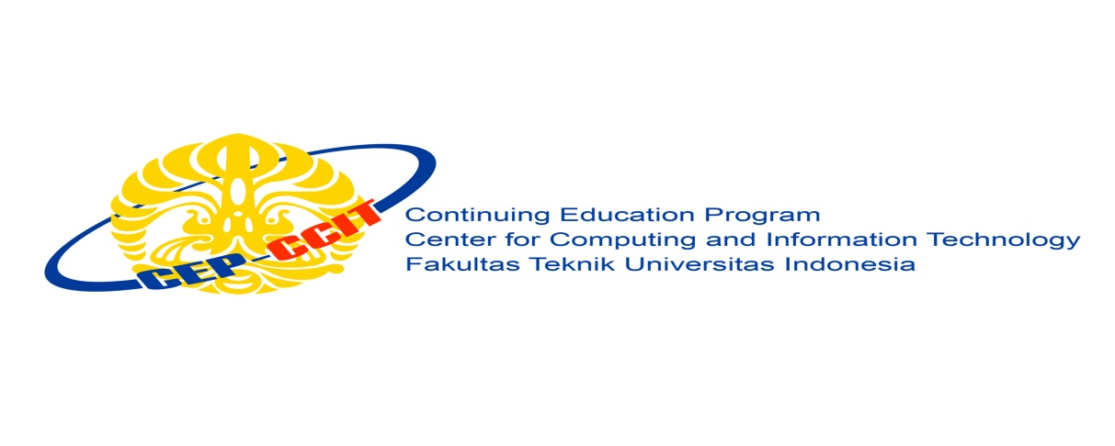

**Information Search and Analysis Skills**

**(ISAS)**

**LINUX MINT OS**

Name : 1. Hilman Maulana Anhar

2. Muhamad Dani Setiawan

Faculty : Muhammad Idham Khalif

Semester : 1

Quarter : 1

Class : 1SC8

Continuing Education Center for Computing and Information Technology Faculty of Engineering, University of Indonesia

2018

**PREFACE**

Praise be to Allah Almighty, Most Merciful, because thanks to His grace and guidance, the writer can arrange and present a paper that contains about Linux Mint OS. The writer also thanked to Mr. Muhammad Idham Khalif as our faculty that have provided guidance to the writer in the process of preparing this paper. Not to forget the writer thank the various parties who have given encouragement and motivation.

The author realizes that in the preparation of this paper there are still many shortcomings and far from perfection. Therefore, the authors expect constructive criticism and suggestions to improve this paper and can be a reference in preparing the papers or subsequent tasks.

The authors also apologize if in writing this paper there are typos and errors that confuse the reader in understanding the author's intent.

**Writer**

**TABLE OF CONTENTS**

PREFACE i

TABLE OF CONTENTS ii

TABLE OF FIGURES iii

TABLE OF TABLES iv

CHAPTER I INTRODUCTION 1

1. Background 1
2. Writing Objective 2
3. Problem Domain 2
4. Writing Methodology 2
5. Writing Framework 2

CHAPTER II BASIC THEORY 4

1. Understanding Operating System 4
2. Understanding Linux OS 5
3. Understanding Linux Mint OS 6

CHAPTER III PROBLEM ANALYSIS 8

1. Version Linux Mint OS 8
2. Advantages and Deficency of Linux Mints OS 9
3. Features of Linux Mint OS 10
4. User Interface of Linux Mint OS 12

CHAPTER IV CONCLUSION AND SUGGESTION 15

1. Conclusion 15
2. Suggestion 15

BIBLIOGRAPHY v

**TABLE OF FIGURES**

Figure 3.1 User Interface of Cinnamon Linux Mint OS 12

Figure 3.2 User Interface of Mate Linux Mint OS 13

Figure 3.3 User Interface of XFCE Linux Mint OS 13

Figure 3.4 User Interface of KDE Linux Mint OS 14

**TABLE OF TABLES**

Table 3.1 Version of Linux Mint OS 8

**CHAPTER I**

**INTRODUCTION**

1. **Background**

Linux is the name given to the Unix type computer operating system. Linux is one example of the results of the development of free software and the main open source. Like free software and other open sources in general, the Linux source code can be modified, used and redistributed freely by anyone.

The name "Linux" comes from the name of the creator, which was introduced in 1991 by Linus Torvalds. The system, system equipment and libraries generally come from the GNU operating system, which was announced in 1983 by Richard Stallman. GNU's contribution is the basis of the emergence of an alternative name GNU / Linux.

Linux has long been known for its use on servers, and is supported by well-known computer companies such as Intel, Dell, Hewlett-Packard, IBM, Novell, Oracle Corporation, Red Hat, and Sun Microsystems. Linux is used as an operating system on various types of computer hardware, including desktop computers, supercomputers, and embedded systems such as electronic book readers, video game systems (PlayStation 2, PlayStation 3 and XBox), mobile phones and routers. Informatics technology observers assume Linux's success because Linux is not dependent on vendors (vendor independence), low operating costs, and high compatibility compared to UNIX versions are not free, as well as high security and stability factors compared to other operating systems such as Microsoft Windows. These characteristics are also evidence of the superiority of open source software development models (opensource software).

Linux Mint is a Linux operating system which is a Linux distribution based on Debian and Ubuntu, with Linux Mint Debian Edition (LMDE) as an alternative based entirely on Debian. Applications that can run on Ubuntu, can also run on Linux Mint. Although the core of LinuxMint is Ubuntu, LinuxMint comes with a different look than Ubuntu.

1. **Writing Objective**

The following is the purpose of writing a paper entitled "Linux Mint OS”:

* Understand version to version of Linux Mint OS
* Understand advantages and deficiency of Linux Mint OS
* Understand features of Linux Mint OS
* Understand the latest user interface of Linux Mint OS

1. **Problem Domain**

In this paper can explain about version, advantages and deficiency, features , and latest user interface (UI) Linux Mint OS.

1. **Writing Methodology**

This paper is written by studying literature review from various sources, either in the form of material from internet or book.

1. **Writing Framework**

**CHAPTER I INTRODUCTION**

* Background
* Writing Objective
* Problem Domain
* Writing Methodology
* Writing Framework

**CHAPTER II BASIC THEORY**

* Understanding Operating System
* Understanding Linux OS
* Understanding Linux Mint OS

**CHAPTER III PROBLEM ANALYSIS**

* Version of Linux Mint OS
* Advantages and Deficiency of Linux Mint OS
* Features of Linux Mint OS
* Latest User Interface (UI) of Linux Mint OS

**CHAPTER IV CONCLUSION AND SUGGESTION**

* Conclusion
* Suggestion

**BIBLIOGRAPHY**

**CHAPTER II**

**BASIC THEORY**

1. **Understanding Operating System**

An operating system (OS) is the program that, after being initially loaded into the computer by a [boot](https://searchwindowsserver.techtarget.com/definition/boot) program, manages all the other programs in a computer. The other programs are called *applications* or application programs. The application programs make use of the operating system by making requests for services through a defined application program interface ([API](https://searchmicroservices.techtarget.com/definition/application-program-interface-API)). In addition, users can interact directly with the operating system through a user interface such as a command line or a graphical user interface ([GUI](https://searchwindevelopment.techtarget.com/definition/GUI)).

An operating system performs these services for applications:

* In a [multitasking](https://whatis.techtarget.com/definition/multitasking) operating system where multiple programs can be running at the same time, the operating system determines which applications should run in what order and how much time should be allowed for each application before giving another application a turn.
* It manages the sharing of internal memory among multiple applications.
* It handles input and output to and from attached hardware devices, such as hard disks, printers, and dial-up ports.
* It sends messages to each application or interactive user (or to a system operator) about the status of operation and any errors that may have occurred.
* It can offload the management of what are called *batch* jobs (for example, printing) so that the initiating application is freed from this work.
* On computers that can provide parallel processing, an operating system can manage how to divide the program so that it runs on more than one processor at a time.

All major computer platforms (hardware and software) require and sometimes include an operating system, and operating systems must be developed with different features to meet the specific needs of various [form factors](https://whatis.techtarget.com/definition/form-factor).

Common desktop operating systems:

1. [**Windows**](https://searchwindowsserver.techtarget.com/definition/Windows) is Microsoft’s flagship [operating system](https://whatis.techtarget.com/definition/operating-system-OS), the [de facto standard](https://whatis.techtarget.com/definition/de-facto-standard) for home and business computers. Introduced in 1985, the [GUI](https://searchwindevelopment.techtarget.com/definition/GUI)-based OS has been released in many versions since then. The user-friendly [Windows 95](https://whatis.techtarget.com/definition/Windows-95) was largely responsible for the rapid development of personal computing.
2. [**Mac OS**](https://whatis.techtarget.com/definition/Mac-OS) is the operating system for Apple's [Macintosh](https://whatis.techtarget.com/definition/Macintosh) line of personal computers and workstations.
3. [**Linux**](https://searchdatacenter.techtarget.com/definition/Linux-operating-system) is a [Unix](https://searchdatacenter.techtarget.com/definition/Unix)-like [operating system](https://whatis.techtarget.com/definition/operating-system-OS) that was designed to provide personal computer users a free or very low-cost alternative. Linux has a reputation as a very efficient and fast-performing system.

A [mobile OS](https://searchmobilecomputing.techtarget.com/definition/mobile-operating-system) allows [smartphones](https://en.wikipedia.org/wiki/Smartphone), [tablet PCs](https://searchmobilecomputing.techtarget.com/definition/tablet-PC) and other mobile devices to run applications and programs. Mobile operating systems include **Apple** [**iOS**](https://searchmobilecomputing.techtarget.com/definition/iOS), **Google** [**Android**](https://searchmobilecomputing.techtarget.com/definition/Android-OS), **BlackBerry OS** and [**Windows 10 Mobile**](https://whatis.techtarget.com/definition/Windows-10-Mobile).

1. **Understanding Linux OS**

Linux (pronounced "lih-nux", not "lie-nux") is a Unix-like [operating system](https://techterms.com/definition/operating_system) (OS) created in 1991 by Linus Torvalds. He developed Linux because he wasn't happy with the currently available options in [Unix](https://techterms.com/definition/unix) and felt he could improve it. So he did what anybody else would do, and created his own operating system.

When Linus finished building a working version of Linux, he freely distributed the OS, which helped it gain popularity. Today, Linux is used by millions of people around the world. Many computer hobbyists (a.k.a. nerds) like the operating system because it is highly customizable. Programmers can even modify the [source code](https://techterms.com/definition/sourcecode) and create their own unique version of the Linux operating system.

[Web hosting](https://techterms.com/definition/webhost) companies often [install](https://techterms.com/definition/install) Linux on their Web servers because Linux-based servers are cheaper to set up and maintain than Windows-based servers. Since the Linux OS is freely distributed, there are no licensing fees. This means Linux servers can host hundreds or even thousands of [websites](https://techterms.com/definition/website) at no additional cost. Windows servers, on the other hand, often require user licenses for each website hosted on the the server.

Linux is available in several distributions. Some of the most popular distributions include Red Hat Enterprise, CentOS, Debian, openSUSE, and Ubuntu. Linux also supports several hardware [platforms](https://techterms.com/definition/platform), including Intel, PowerPC, DEC Alpha, Sun Sparc, and Motorola. Since Linux is compatible with so many types of hardware, variations of the Linux operating system are used for several other electronic devices besides computers. Some examples include cell phones, cable boxes, and Sony's PS2 and PS3 gaming consoles.

1. **Understanding Linux Mint OS**

Linux Mint is a free and [open source](https://whatis.techtarget.com/definition/open-source) operating system ([OS](https://whatis.techtarget.com/definition/operating-system-OS)) [distribution](https://searchdatacenter.techtarget.com/definition/distribution) based on [Ubuntu](https://searchdatacenter.techtarget.com/definition/Ubuntu) and [Debian](https://searchdatacenter.techtarget.com/definition/Debian) for use on [x-86](https://searchwindowsserver.techtarget.com/definition/x86) [x-64](https://whatis.techtarget.com/definition/x86-64)-compatible machines.

Mint is designed for ease of use and a ready-to-roll out-of-box experience, including [multimedia](https://searchmicroservices.techtarget.com/definition/multimedia) support on desktops. The operating system is easier to install than most [Linux](https://searchdatacenter.techtarget.com/definition/Linux-operating-system) distributions. Mint includes software required for e-mail and online functionality as well as support for multimedia content, whether online or from a user's own files and physical media.

Unlike most Linux distributions, Mint includes proprietary third-party [browser](https://searchwindevelopment.techtarget.com/definition/browser) [plugins](https://whatis.techtarget.com/definition/plug-in), Java, media [codecs](https://searchunifiedcommunications.techtarget.com/definition/codec), and other components to enable support for common accepted standards. This support allows for DVD and BluRay playback, as well as Flash for [streaming media](https://whatis.techtarget.com/definition/streaming-media). Although the OS includes a [firewall](https://searchsecurity.techtarget.com/definition/firewall), Mint claims to have no need of [antimalware](https://searchsecurity.techtarget.com/definition/antimalware). Mint is compatible with Ubuntu installer, which enables access to 30,000 existing pieces of free, open source software.

There are several different desktop editions of Mint, including Cinnamon, GNOME, XFCE and KDE, to best support various hardware. The operating system is also provided in an alternate Linux Mint Debian Edition for those that are more familiar with Linux. That edition is said to be less intuitive and user-friendly but also faster and more responsive.

**CHAPTER III**

**PROBLEM ANALYSIS**

1. **Version of Linux Mint OS**

Linux Mint releases 2 times a year. Each Linux Mint release is given a version number and code name that uses the names of women and always end in "A" (example: Linux Mint 14 Nadia, 14 is the version number and Nadia is the code name ending in "a").

|  |  |  |
| --- | --- | --- |
| Version | Code Name | Release Date |
| 1.0 | Ada | 2006-08-27 |
| 2.0 | Barbara | 2006-11-13 |
| 2.1 | Bea | 2006-12-20 |
| 2.2 | Bianca | 2007-02-20 |
| 3.0 | Cassandra | 2007-05-30 |
| 3.1 | Celena | 2007-09-24 |
| 4.0 | Daryna | 2007-10-15 |
| 5 | Elyssa | 2008-06-08 |
| 6 | Felicia | 2008-12-15 |
| 7 | Gloria | 2009-05-26 |
| 8 | Helena | 2009-11-29 |
| 9 | Isadora | 2010-05-18 |
| 10 | Julia | 2010-11-12 |
| 11 | Katya | 2011-05-26 |
| 12 | Lisa | 2011-11-26 |
| 13 | Maya | 2012-05-23 |
| 14 | Nadia | 2012-11-20 |
| 15 | Olivia | 2013-05-29 |
| 16 | Petra | 2013-11-30 |
| 17 | Qiana | 2014-05-31 |
| 17.1 | Rebecca | 2014-11-29 |
| 17.2 | Rafaela | 2015-08-17 |
| 17.3 | Rosa | 2015-12-04 |
| 18 | Sarah | 2016-06-30 |

**Table 3.1 Version of Linux Mint OS**

**Note:** Old version Old version, but still be supported and have an update Current version Next version

1. **Advantages and Deficiency of Linux Mint OS**

**Advantages of Linux Mint OS:**

* Its use makes it easy for users because linux mint is a derivative of ubuntu so the tools are almost the same as ubuntu.
* The installation process is fairly easy.
* The space needed to install Linux Mint OS is not too large.
* Looks attractive and elegant.
* Is a Linux that is widely used by most people.
* It's integrated with Java Runtime.

**Deficiency of Linux Mint OS:**

* Linux Mint hardware resources are lacking.
* Stable release is out of date.

1. **Features of Linux Mint OS**
   * + 1. **Graphic**

* **Document Viewer**, This application is used to read documents (especially those that have a .pdf format).
* **GIMP Image Editor**, this application is used to process images (photos). This application can be said as Photoshop Linux.
* **gThumb**, this application is used to view and organize the images and photos we have.
* **Image Viewer**, used to browse and rotate images (photos)
* **Simple Scan**, used to scan documents.
  + - 1. **Internet**

The applications contained there in are:

* **Desktop Sharing**, this application is used so that other people (other users) can see the desktop that we have.
* **Firefox Web Browser**, one of the browsers that many people use to explore cyberspace.
* **Sun Java 6 Web Start**, an application for running Java.
* **Thunderbird Mail**, an application for sending and receiving e-mail using Thunderbird (Mail client).
* **XChat IRC**, used to chat with other people using Internet Relay Chat.
  + - 1. **Office**

This section can be said to be Microsoft's Linux Office:

* **LibreOffice Base**, used to process data bases.
* **LibreOffice Calc**, used to process data in the form of numerical operations (such as Excel in Microsoft Office).
* **LibreOffice Draw**, used to design, edit, create flowcharts, logos and others that use vectors (points and lines).
* **LibreOffice Impress**, used to make presentations (such as Powerpoint in Microsoft Office).
* **LibreOffice Writer**, used to process data in the form of writing (such as Word in Microsoft Office).
  + - 1. **Sound & Video**

Applications included in this group are:

* **Banshee**, an application for editing and organizing media collections both audio and video.
* **Brasero**, used for making and copying CDs / DVDs (like Nero on Windows).
* **GNOME MPlayer**, an application for playing audio and video media. This application can be used to rip off almost all existing media formats.
* **Movie Player**, as the name suggests this application is used to play movies and videos, almost all video formats are known to be able to use this application.
* **Sound Recorder**, used to record what we say.
* **VLC Media Player**, can be used to play almost all media both audio and video.
* **Volume Control**, used to adjust the volume.

1. **User Interface (UI) of Linux Mint OS**

Linux mint comes with a beautiful and easy to use interface. So it is suitable for beginners and for everyday computer use. Thus besides Ubuntu, Linux Mint is a very appropriate alternative to replace your Windows operating system.

Although from Ubuntu, Linux mint has its own interface package, Cinnamon and Mate.

1. **Cinnamon**

Cinnamon is a desktop that is very beautiful and elegant, and is perfect for those of you who like fancy desktops. With a luxurious look, of course Linux Mint Cinnamon will be very good if your computer hardware specifications are fairly mode.

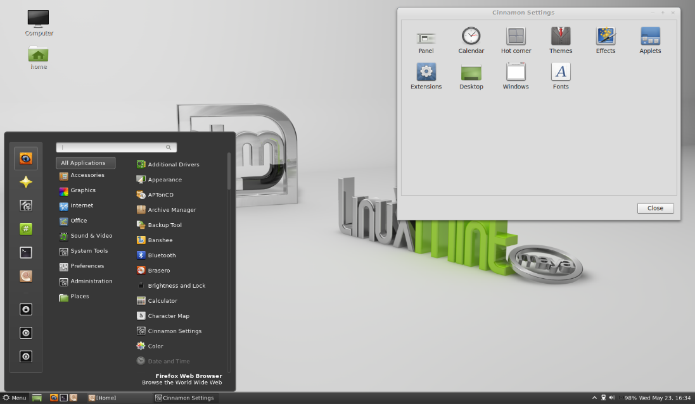

**Figure 3.1 User Interface of Cinnamon Linux Mint OS**

1. **Mate**

Mate, is a simple and lightweight desktop developed from GNOME 2. Mate can be enhanced with luxurious effects by installing CCSM applications. Mate works well in modern and old hardware specifications.

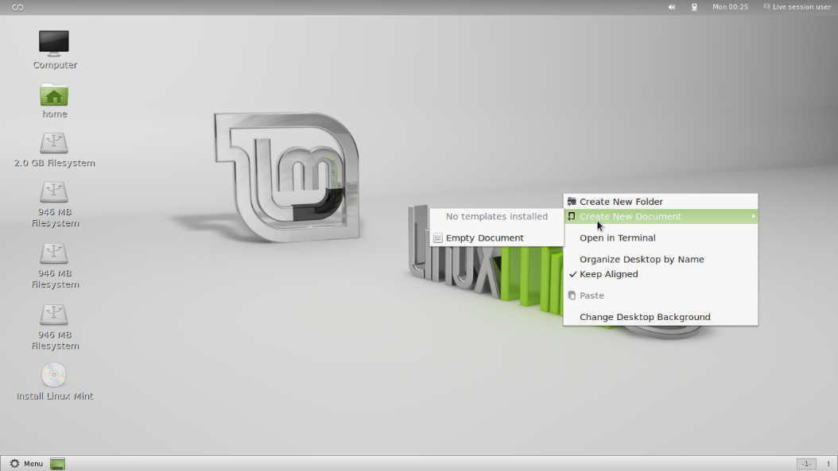

**Figure 3.2 User Interface of Mate Linux Mint OS**

In addition to using the Cinnamon and Mate desktop, Linux Mint also offers KDE and XFCE desktops. So that with the presence of a varied desktop will give you a freedom to choose Linux Mint in accordance with the hardware specifications you have.

1. **XFCE**

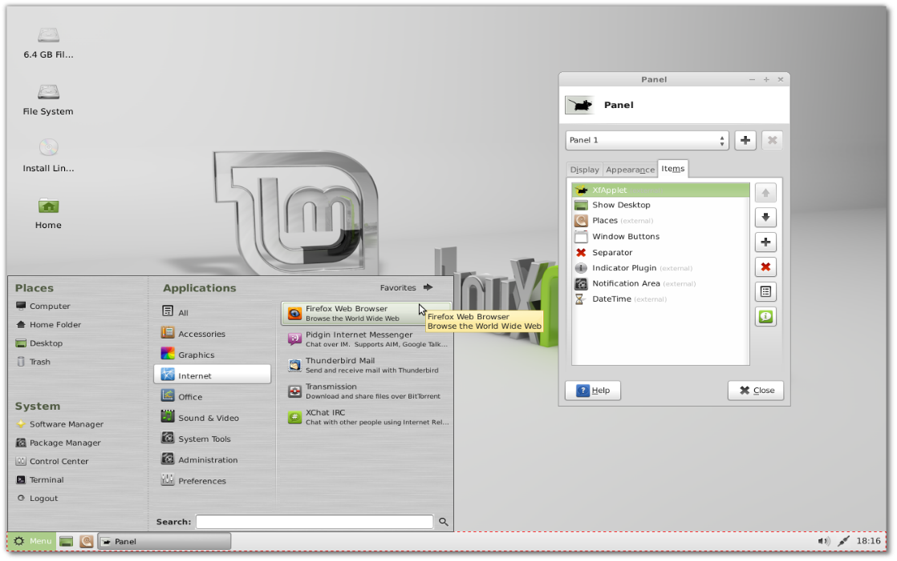

**Figure 3.3 User Interface of XFCE Linux Mint OS**

1. **KDE**

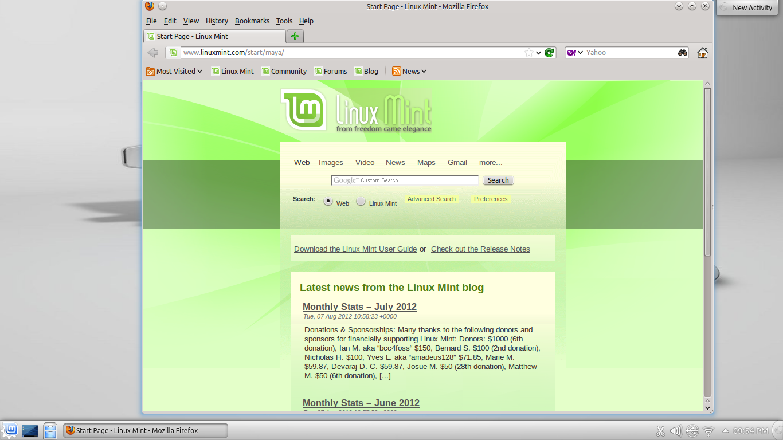

**Figure 3.4 User Interface of KDE Linux Mint OS**

**CHAPTER IV**

**CONCLUSION AND SUGGESTION**

1. **Conclusion**

Linux Mint will continue to be an elegant,100% free operating system and Linux operating system based on the Ubuntu operating system. This operating system offers paid to both companies and individuals.

1. **Suggestion**

Hopefully with the development of increasingly advanced technology, the development of Linux users is also increasing. And this operating system can make it easier for users to install and operate the Linux Mint Operating System.

**BIBLIOGRAPHY**

Utami, Rosiana Budi. “LINUX MINT 9 (ISADORA)”. 10 September 2018. https://www.scribd.com/doc/43943967/MAKALAH-Linux-Mint

Muksidin. “Linux Mint”. 12 September 2018. https://muksidintaslim.com/p/linux-mint_30.html

Rouse, Margaret. “Linux Mint”. 8 September 2018. https://whatis.techtarget.com/definition/Linux-Mint

Rouse, Margaret. “operating system (OS)”. 8 September 2018. https://whatis.techtarget.com/definition/operating-system-OS

Sistem Operasi Komputer. “Kelebihan dan Kekurangan Linux”. 10 September 2018. https://www.sistemoperasikomputer.com/2013/04/kelebihan-dan-kekurangan-linux.html

TechTerms. “Linux”. 8 September 2018. https://techterms.com/definition/linux